Lab: Stacks and Queues
Problems for the "C# Advanced" course @ Software University.
Check your solutions in SoftUni Judge: https://judge.softuni.org/Contests/1445/Stacks-and-Queues-Lab.
- Working with Stacks

Reverse a String
Create a program that:
- Reads an input string
- Reverses it backwards (letter by latter, from the last to the first) using a Stack<T>
- Prints the result back at the console

Examples
Input | Output
I Love C# | #C evoL I
Stacks and Queues | seueuQ dna skcatS

Hints
- Use a Stack<string> and the methods Push(), Pop().
- Push all chars from the input string, then pop and print them one by one.

Stack Sum
Create a program that:
- Reads an input of integer numbers and adds them to a stack.
- Reads and executes commands until "end" is received.
- Process the following commands:
  - Add <n1> <n2>: pushes two numbers into the stack
  - Remove <n>: removes the n elements from the stack or does nothing if the stack holds less than n elements.
- Prints the sum of the remaining elements of the stack.

Input
- On the first line, you will receive an array of integers (space-separated).
- On the next lines, until the "end" command is given, you will receive commands – a single command and one or two numbers after the command, depending on what command you are given.
  - If the command is "add", you will always be given exactly two numbers after the command, which you need to add to the stack.
  - If the command is "remove", you will always be given exactly one number after the command, which represents the count of the numbers you need to remove from the stack. If there are not enough elements, skip the command.
- Commands are case-insensitive, which means that “Add”, “add” and “aDD” are the same command.
- A single space is used as a separator between commands and numbers.

Output
- When the command "end" is received, you need to print the sum of the remaining elements in the stack.

Examples
Input | Output | Comments
1 2 3 4  adD 5 6  REmove 3  eNd | Sum: 6 | The stack initially holds [1, 2, 3, 4].  After the “Add 5 6” command, the stack holds [1, 2, 3, 4, 5, 6].  After the “Remove 3” command, the stack holds [1, 2, 3].  The sum of the elements [1, 2, 3] is 6.
3 5 8 4 1 9  add 19 32  remove 10  add 89 22  remove 4  remove 3  end | Sum: 16 | The stack initially holds [3, 5, 8, 4, 1, 9].  The stack now holds [3, 5, 8, 4, 1, 9, 19, 32].  The command “Remove 10” is ignored (not enough elements).  The stack now holds [3, 5, 8, 4, 1, 9, 19, 32, 89, 22].  The stack now holds [3, 5, 8, 4, 1, 9].  The stack now holds [3, 5, 8].  The sum of the elements [3, 5, 8] is 16.

Hints
- Use a Stack<int>
- Use the methods Push(), Pop()
- Commands may be given in mixed case.

Simple Calculator
Create a simple calculator that can evaluate simple expressions with only addition and subtraction. There will not be any parentheses. Numbers and operations are space-separated.
Solve the problem using a Stack.

Examples
Input | Output
2 + 5 + 10 - 2 - 1 | 14
2 - 2 + 5 | 5

Hints
- Split the input expression by space to extract its tokens (numbers and operations).
- Reverse the input tokens, then push them in a Stack<string>.
- Example:
  - Input expression: 2 + 5 + 10 - 2 - 1
  - Stack: 1 - 2 - 10 + 5 + 2
- Pop the last number (in the above example 2). It is the current result.
- Pop an operation and number (e. g. + 5). Execute the operation. In our example: result = 2 + 5 = 7.
- Repeat the previous step until the stack gets empty.

Matching Brackets
We are given an arithmetic expression with brackets. Scan through the string and extract each sub-expression.
Print the result back at the terminal.

Examples
Input | Output
1 + (2 - (2 + 3) * 4 / (3 + 1)) * 5 | (2 + 3)  (3 + 1)  (2 - (2 + 3) * 4 / (3 + 1))
(2 + 3) - (2 + 3) | (2 + 3)  (2 + 3)

Hints
- Scan through the expression from its start to its end, searching for brackets.
  - If you find an opening bracket, push its index (position in the input expression) into the stack.
  - If you find a closing bracket pop the topmost element from the stack. This is the index of the opening bracket.
  - Use the current and the popped index to extract the sub-expression.
- Working with Queues

Print Even Numbers
Create a program that:
- Reads an array of integers and adds them to a queue.
- Prints the even numbers separated by ", ".

Examples
Input | Output
1 2 3 4 5 6 | 2, 4, 6
11 13 18 95 2 112 81 46 | 18, 2, 112, 46

Hints
- Parse the input and enqueue all the numbers in a Queue<int>.
- Dequeue the elements one by one and print all even values.

Supermarket
You are given a sequence of input strings, each staying on a separate line. Each input string holds either a customer name, or the command “Paid” or the command “End”. Your task is to read and process the input:
- When you receive a customer name, add it to the queue.
- When you receive the "Paid" command, print the customer names from the queue (each at separate line), then empty the queue.
- When you receive the "End" command, print the count of the remaining customers from the queue in the format: "{count} people remaining." and stop processing the commands (see the examples below).

Examples
Input | Output
Liam  Noah  James  Paid  Oliver  Lucas  Logan  Tiana  End | Liam  Noah  James  4 people remaining.
Amelia  Thomas  Elias  End | 3 people remaining.

Hints
Use a queue and follow the description. Just read and implement the commands.

Hot Potato
Hot potato is a game in which children form a circle and start passing a hot potato. The counting starts with the first kid. Every n^{th} toss the child left with the potato leaves the game. When a kid leaves the game, it passes the potato along to its next neighbor. This continues until there is only one kid left.
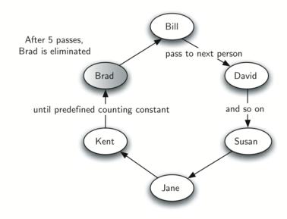
Create a program that simulates the game of Hot Potato. Print every kid that is removed from the circle. In the end, print the kid that is left last.

Examples
Input | Output
Alva James William  2 | Removed James  Removed Alva  Last is William
Lucas Jacob Noah Logan Ethan  10 | Removed Ethan  Removed Jacob  Removed Noah  Removed Lucas  Last is Logan
Carter Dylan Jack Luke Gabriel  1 | Removed Carter  Removed Dylan  Removed Jack  Removed Luke  Last is Gabriel
Illustration for the first example (Alva + James + William, n=2):
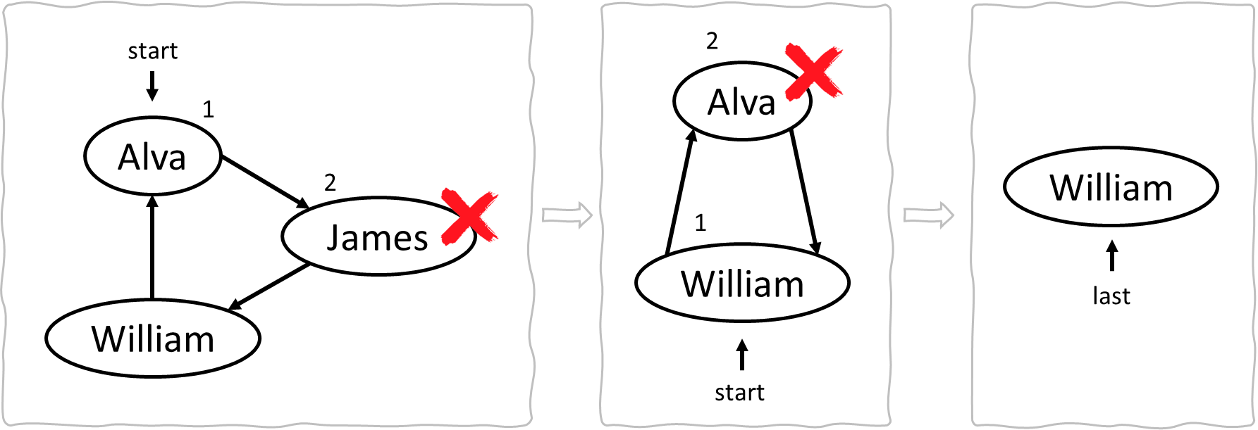

Hints
- Enqueue all kids in a Queue<string>.
- For each round do the following:
  - (n-1) times deque an element and enqueue it again.
  - Remove an element and print it (this is the n^{th} element).
- Repeat the above until the queue remains holding only 1 element.

Traffic Jam
Create a program that simulates the queue that forms during a traffic jam. During a traffic jam, only N cars can pass the crossroads when the light goes green. Then the program reads the vehicles that arrive one by one and adds them to the queue. When the light goes green N number of cars pass the crossroads and for each, a message "{car} passed!" is displayed. When the "end" command is given, terminate the program and display a message with the total number of cars that passed the crossroads.

Input
- On the first line, you will receive N – the number of cars that can pass during a green light.
- On the next lines, until the "end" command is given, you will receive commands – a single string, either a car or "green".

Output
- Every time the "green" command is given, print out a message for every car that passes the crossroads in the format "{car} passed!".
- When the "end" command is given, print out a message in the format "{number of cars} cars passed the crossroads.".

Examples
Input | Output
4  Hummer H2  Audi  Lada  Tesla  Renault  Trabant  Mercedes  MAN Truck  green  green  Tesla  Renault  Trabant  end | Hummer H2 passed!  Audi passed!  Lada passed!  Tesla passed!  Renault passed!  Trabant passed!  Mercedes passed!  MAN Truck passed!  8 cars passed the crossroads.
3  Enzo's car  Jade's car  Mercedes CLS  Audi  green  BMW X5  green  end | Enzo's car passed!  Jade's car passed!  Mercedes CLS passed!  Audi passed!  BMW X5 passed!  5 cars passed the crossroads.

